BENTON FOUNDATION TRUSTEES AND BOARD
OF DIRECTORS
Leonard J. Schrager, Chairman and Trustee
Marjorie Craig Benton, Trustee
Adrianne B. Furniss, Trustee
___________________
Robert A. Cohen, Secretary
Elizabeth M. Daley
Terry Goddard
Austin L. Hirsch, Counsel
Joanne Hovis
Jim Kohlenberger
Handy Lindsey
Michael Smith, Treasurer

BENTON FOUNDATION STAFF
Adrianne B. Furniss, Kevin Taglang,
Amina Fazlullah, Kip Roderick,
Robbie McBeath, Rita Cook

The family encourages gifts to honor Charles’ lifelong passion, the Benton Foundation, and its efforts to ensure that media and telecommunications serve the public interest and enhance democracy. Benton Foundation, which will celebrate its 35th anniversary in 2016, is a private operating foundation and 501(c)(3) tax-exempt organization. Contributions can be sent to:
Benton Foundation
1560 Sherman Ave, Suite 440
Evanston, IL 60201

DRAWING OF CHARLES Lily Furniss

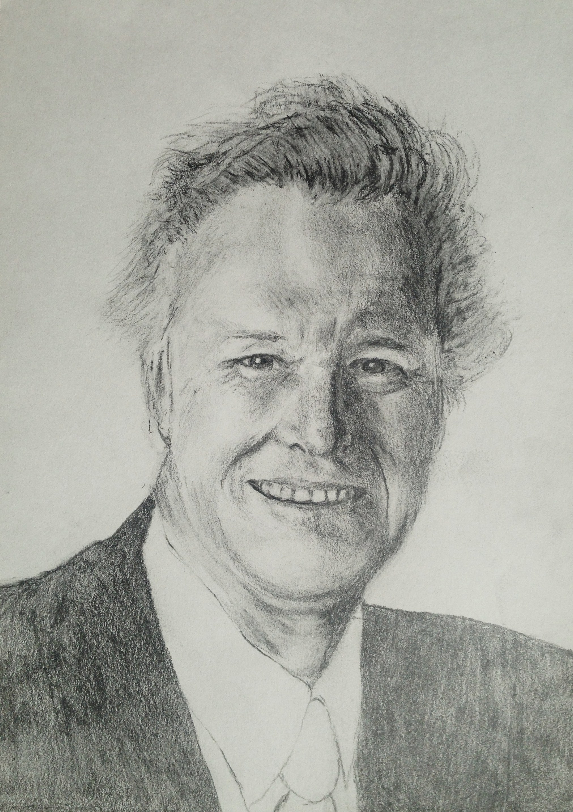
There’s so much to celebrate
CHARLES BENTON
1931-2015
Thursday, November 19, 2015
4-6pm
First Congregational UCC
Washington DC

SPEAKERS
RICHARD SOMERSET-WARD spent 21 years on the staff of the BBC, latterly as its Head of Music & Arts. He has lived in the USA since 1984 and is a former Fellow of the Benton Foundation. He writes about opera and theater, as well as about the harnessing of digital technologies.

JOANNE HOVIS is an attorney and recognized authority on the broadband market and community broadband topics—and on the evolving role of government and public utilities in the provision of communications services to the public. Joanne is President of CTC Technology & Energy, CEO of the Coalition for Local Internet Choice (CLIC), and former President of the National Association of Telecommunications Officers and Advisors (NATOA). She is also a member of Board of Directors of the Benton Foundation.

GIGI B. SOHN serves as Counselor to the Chairman in the Office of FCC Chairman Tom Wheeler. In that capacity, she advises on a range of telecommunications and media issues and represents the Chairman in a variety of public forums around the country. From 2001-2013, Gigi was the President and CEO of Public Knowledge and, from 2011-2013, was Co-Chair of the Board of Directors of the Broadband Internet Technical Advisory Group (BITAG). Prior to that, she served as a Project Specialist in Ford Foundation’s Media, Arts and Culture unit and as Executive Director of the Media Access Project.

MICHAEL COPPS served as a commissioner on the Federal Communications Commission from May 2001 to December 2011 and was the FCC's Acting Chairman from January to June 2009. In 2012, Michaels joined Common Cause to lead its Media and Democracy Reform Initiative. Michael writes a monthly column for Benton Foundation’s Digital Beat Blog on issues exploring the public interest in communications.

ADRIANNE B. FURNISS is the Executive Director of the Benton Foundation.

Welcome and Introductions
Richard Somerset-Ward

Joanne Hovis

Gigi B. Sohn

Michael Copps

Video

Closing Remarks
Adrianne B. Furniss

